# **Destructuring Exercise**

Object Destructuring 1

What does the following code return/print?

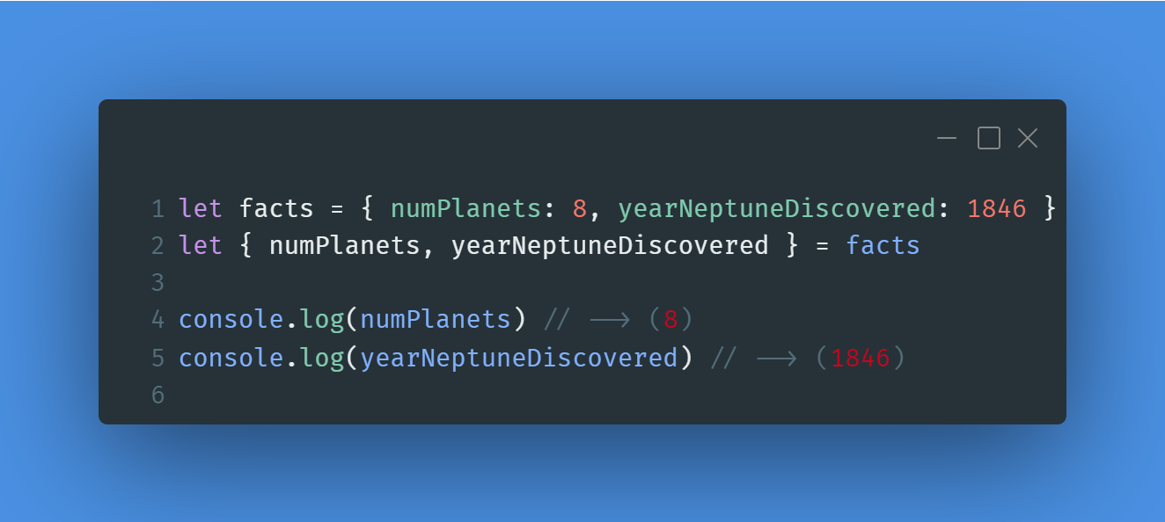

Object Destructuring 2

What does the following code return/print?

Object Destructuring 3

What does the following code return/print?

Array Destructuring 1

What does the following code return/print?

Array Destructuring 2

What does the following code return/print?

Array Destructuring 3

What does the following code return/print?

